Cloud Computing

Assignment 2 – Shell Scripting

Name: Pranav Rao

Roll No: 333045

Division: IT-C

Batch: C2

**Theory:**

1) What is Shell (Linux kernel architecture diagram)

A Shell provides you with an interface to the Unix system. It gathers input from you and executes programs based on that input. When a program finish executing, it displays that program's output. Shell is an environment in which we can run our commands, programs, and shell scripts. There are different flavors of a shell, just as there are different flavors of operating systems. Each flavor of shell has its own set of recognized commands and functions. A Shell reads your input after you press Enter. It determines the command you want executed by looking at the first word of your input. A word is an unbroken set of characters. Spaces and tabs separate words.

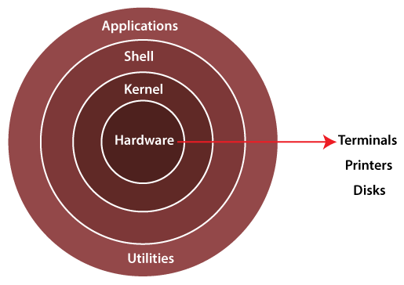

2) Types of shell

The shell is mainly of two types, then these two types are further categorized: types of

shell is:

● Bourne Shell

• Bourne shell is known as the first shell to be introduced, it is represented by “sh”. This shell got popular because of its quite compact nature.

• It was made the default shell for the SOLARIS operating system and was used as a Solaris administration script. It has very high-speed operations

• Bourne’s shell was not able to handle logical and arithmetic operations. It was less interactive because of the lack of comprehensive features. Also, it is not able to recall previously used commands.

• The Bourne shell can be further divided into 5 types.

1. Bourne shell (sh)

2. Korn Shell (ksh)

3. Bourne Again shell (bash)

4. POSIX shell (sh)

● C Shell

• The C shell was designed by Bill Joy at the University of California. It is represented using “csh”.

• The C shell was designed with the purpose of supporting programming languages.

• It was specifically designed to support in-built features like solving arithmetic operations and syntax of programming languages like C.

• Unlike Bourne and other Linux shells, the C shell can maintain and history of previously used commands, and those commands can be used whenever required.

• Shell is the most important and powerful tool in the system. Without a shell, it’s

impossible to utilize the system’s features and functionality to its fullest.

**Problem statements for shell scripting:**

2a) Write a shell script to check user is root user or not

CODE:

#!/bin/bash

echo "Enter User:"

read name

if [ `id -u $name` -eq 0 ]

then echo "The user is root"

else

echo "The user is not root"

fi

OUTPUT:

2b) Write a shell script to install any particular software (ex: java or python)

CODE:

# !/bin/sh

echo "Enter a package name: "

read packageName

$packageName --version

if [ "$?" -ne 0 ]; then

echo "Package not installed\nDo you want to install it?[Y/N]"

read choice

if [ $choice == "y" ] || [ $choice == "Y" ]; then

sudo apt-get update

sudo apt-get install $packageName

else

exit

fi

else

echo "Package already installed"

exit

fi

OUTPUT:

2c) Write a shell script to check disk usage of the system and if disk usage is more than 90% it should send an email to system admin. This script should run everyday at 8:00 AM.

CODE:

# !bin/sh

df -Ph | grep -vE '/Filesystem|tmpfs|cdrom' | awk '{ print $5,$1 }' |

while read output;

do

echo $output

used=$(echo $output | awk '{print $1}' | sed s/%//g)

partition=$(echo $output | awk '{ print $2 }')

if [ $used -gt 90 ]; then

echo "The partition \"$partition\" on $(hostname) has used $used%

at $(date)" | mail -s "Disk Space Alert: $used% Used On $(hostname)"

kali@kali

echo "Email sent regarding $partition"

else

echo "Disk space usage is in under control"

fi

done

OUTPUT:

2d) write a shell script to take mysql database server backup. This script should run weekly on every sunday at 11:00 PM.

CODE:

#! /bin/sh

echo "starting database backup"

db_backup="mydb.gz"

sudo mysqldump -uroot -p test | gzip -c > ./db_backups/${db_backup}

if [ "$?" -eq 0 ]; then

echo "db backup complete"

else

echo "db backup failed"

fi

# sudo chmod +x ./backup.sh (Run in terminal from this folder)

# sudo crontab -e

# 0 23 * * 0 sudo ./backup.sh > /dev/null 2>&1

OUTPUT:

For 2d) The executable files are added to crontab

